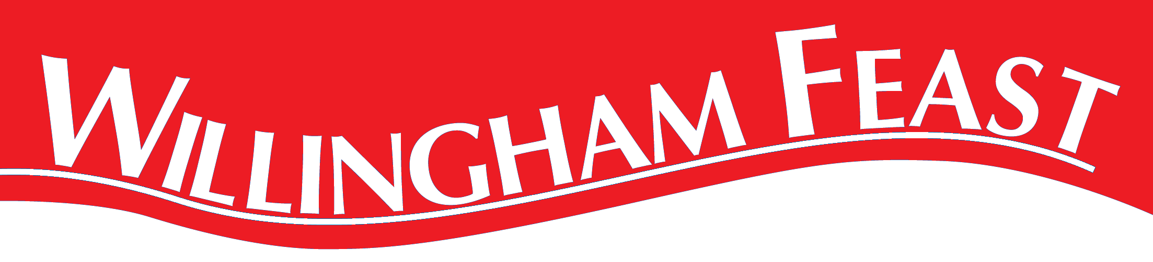
Dog Show Running Order
1. Waggiest Tail
2. Most Appealing Eyes
3. Best Trick
4. Most Sociable
5. Best Veteran - Any breed (7 years and over)
6. Best Rescue Dog - Any dog that has come from an animal shelter
7. Best Brace - 2 dogs alike
8. Best Irish Brace - 2 dogs of different types
9. Best 6 legs - Dog and handler
10. Dog the judges would most like to take home
Plus prizes for winners/runners up of the Scurry Speed, Hooper Agility and Treats Trail Obedience challenges

